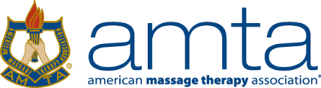

2022 ESSAY CONTEST APPLICATION
First Name: _________________________________ Last Name:_____________________________
Address: ___________________________________________________ Date:_________________
Phone: _____________________________________ Email: ___________________________________
School Name: ________________________________ Anticipated Graduation Date: ________________
School Address: ________________________________________________________________________

In a few sentences, please share why you want to be a massage therapist: ________________________
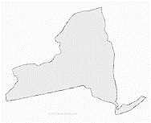
_______________________________________________________________________________________________________________________________________________________________________________________________________________________________________________________________
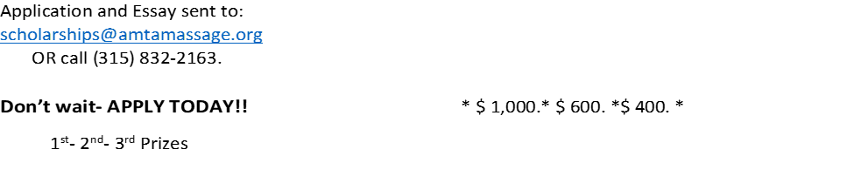
You must currently be enrolled, or admitted, in a 500-hour minimum entry level massage therapy program at the time you apply for the scholarship.
The recipients will be announced at the 2022 Annual AMTA Convention and will be listed on amtamassage.org/scholarships

Prizes are; 1st-$1000 2nd- $600 3rd- $400
APPLICATION DEADLINE: January 15, 2022
ESSAY SUBMISSION DEADLINE: March 1 2022
2022 CONVENTION ANNOUNCEMENT: April 30, 2022.

